

user Guide v1

(For V.7.21 – Updates in Progress)

**1/26/16**

# Table of contents

**PAGE #**

Table of contents 2

overview 4

The Data 5

Step 1: Format the data 5

Glyph Designer 6

STEP 2: Open up Glyph Designer 6

STEP 3: Plan the Glyph design by examining the data 7

STEP 4: Look at finished glyph 7

STEP 5: start at the top of the glyph tree 8

Step 6: Create a branch / child for the medal counts 10

Step 7: create an element for age 11

STEP 8: We’re done building the glyph 11

Data Mapper 12

STEP 9: Open up the data Mapper 12

STEP 10: get the MapQuest Key and add it to the data mapper 13

STEP 11: import the data and assign fields 14

Step 12: Import Glyph 15

Step 13: Define base image 16

Step 14: map data to glyph 17

Step 15: addING the Tag & Description information 20

Step 16: MAPPING DATA TO SHAPES 21

Step 17: Save file 22

Glyph Viewer 22

Portable Viewer 24

General Navigation 24

Exporting to Portable Viewer 24

how to guide 26

Background Image 26

Add a Glyph Legends 29

Modify the Glyphs and Add new information 31

add more data and remove some rows 31

modify the rotation values to make the glyph elements orient correctly 33

sizing elements 34

Max/Min Guidelines for Data Mapper 34

Glyph Designer Alignment Charts 35

# overview

This guide will establish a baseline competency to get from raw data to an accurate 3D visualization. As you navigate through each section, there will be several tips and tricks to get the most out of the V7.21 toolset as well as common pitfalls and solutions.

**The Data:**

* Will need to be correctly formatted in either **CSV** or **SQLite** format using standard tools

**The SynGlyphX Package includes:**

* **Glyph Designer**: This tool creates the glyph(s) that is/are mapped to the data
* **Data Mapper**: Used to map the data to glyph elements and define visual attributes
* **Glyph Visualizer**: Used to view, filter, and animate the mapped data in a 3D environment
* **Portable Viewer**: An alternate Visualizer that can be sent to individuals lacking the SynGlyphX Package

**The illustration below shows how the data and the SynGlyphX Package interacts:**

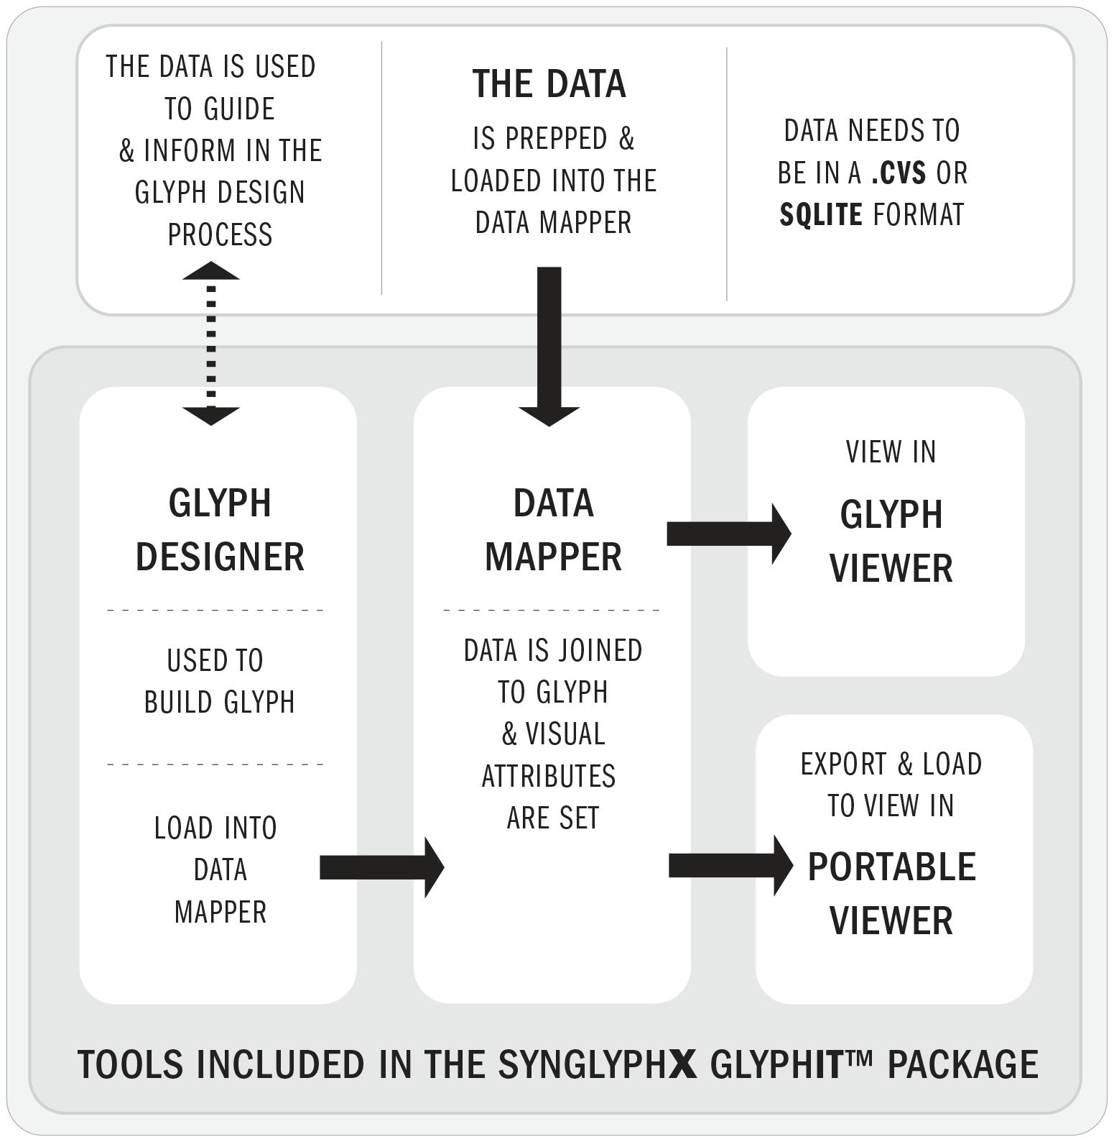

# The Data

#### As of V 7.21 the following relational databases can be properly loaded into Data Mapper:

* CSV files
* SQLite files

## Step 1: Format the data

The sample data and other files needed to complete this demo will be provided in the “SampleData” Folder in the following location: **C:\Program Files (x86)\SynGlyphX\GlyphBuilder\SampleData**

The Excel data we are using for this demo is called **Quickstart_Sample_Data_Olympics.csv**. In it we have created a short list of Olympic athletes with the medals won, age, sex, date, and hometown.

**See below:**

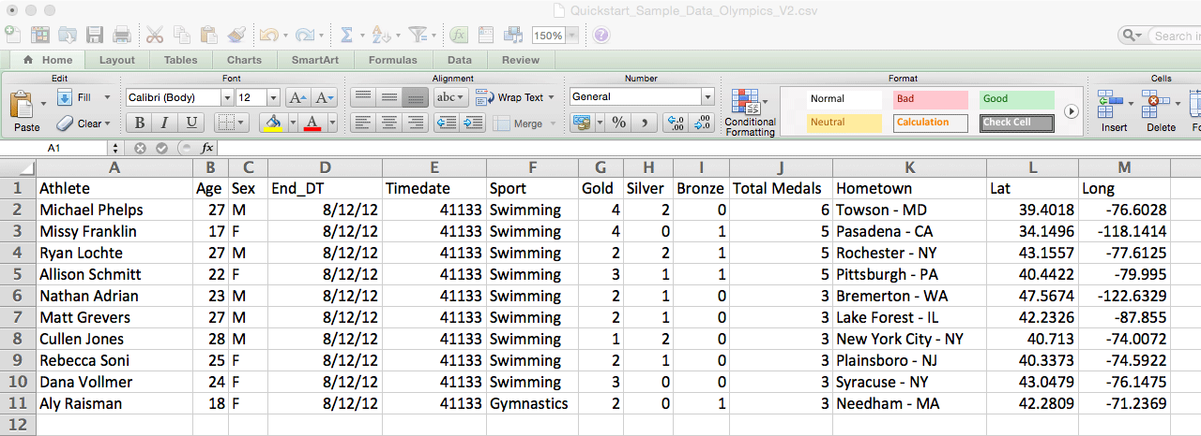

NOTES:

It is perfectly fine to begin working in Glyph Designer first, but once you decide to create a project from start to finish, we highly suggest that you first **finalize and format your data source** in order to minimize reworking it later.

Currently, Data Mapper is unable to deal with “Date” types. Due to this restriction, the End_DT field (end date) has been converted to a number (Timedate) and will be used in the Z-axis field.

There are latitude and longitude values as every glyph must be positioned somewhere on the 3D field of view. If there are no position coordinates, the system will assign everything to a default and glyphs may end up stacked and in undesirable positions. See the “Background Image” section in the “How To Guide” for more information.

# Glyph Designer

## STEP 2: Open Glyph Designer

#### The blank window should look like the image below:

This is your blank canvas in which to create a Glyph. You will need to define geometric shapes for each data field you desire to map and visualize. The data file will only be used as reference at this step and cannot interact with Glyph Designer.

The window on the left side is the “Glyph Tree” and shows all data elements that exist in the field of view. The default shape is a **Pin:Pin (Root)** with a single **Torus:Torus** child shape as seen in the middle column. The standard world map being shown is the default background image. The “Properties” column on the right shows all the shape attributes that can be modified and assigned. Note that all of these properties can be later changed in Data Mapper.

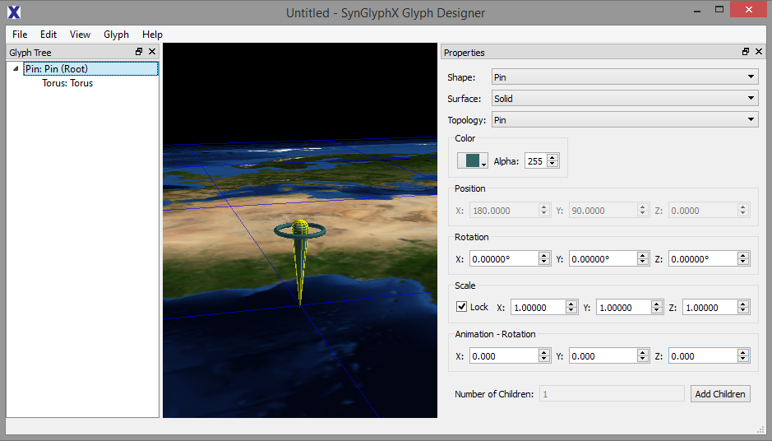

## STEP 3: Plan the Glyph design by examining the data

In our Olympic Athletes demo we will map these data fields to shapes:

* Location
* Date
* Age
* Sex (M/F)
* Medal Count (Gold/Silver/Bronze/Total)

For the time being we will map these text fields primarily as labels:

* Name
* Hometown
* Sport

NOTE: It will be easier to map numeric fields to glyph elements and will provide more flexibility to the user. If there is a way to logically transform your text data into numeric data, we would recommend doing so to save time later in the data mapping phase.

## STEP 4: Look at ThE finished SAMPLE glyph

You are free to creatively decide how to display multiple elements. In this quick start guide, we will show how to create a glyph that looks like what is shown below. Notice the column on the left, “Glyph Tree” and the column on the right “Properties”. But let’s take it step by step and show you how to build this glyph.

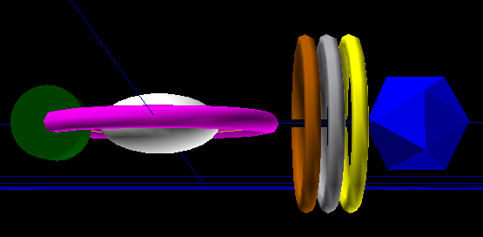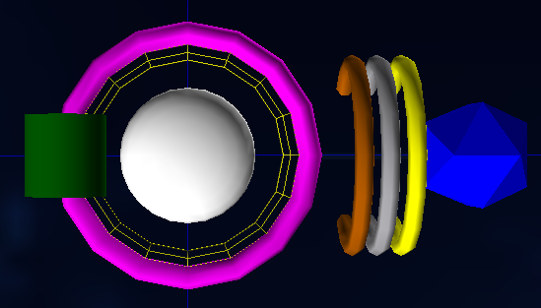

## STEP 5: start at the top of the glyph tree

1. Click on the first shape in the “Glyph Tree” to select that shape. In the “Properties” menu the default shape is **Shape: Pin: Topology: Pin (Root)**; change that to **Shape: Cylinder Topology: Rod (Root)**. The glyph should look like the image below.

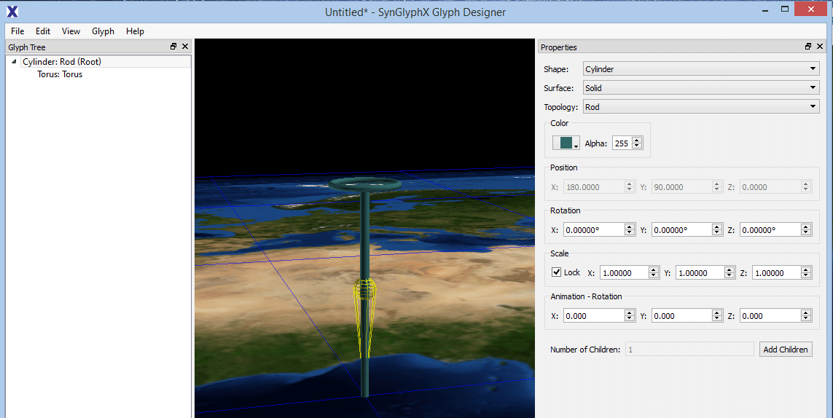

1. In the “Properties” menu, change the scale to 0 (0.0000). Because the default is “Lock” you can change one of the X/Y/Z values and it will make everything zero. The glyph should look like the image below.

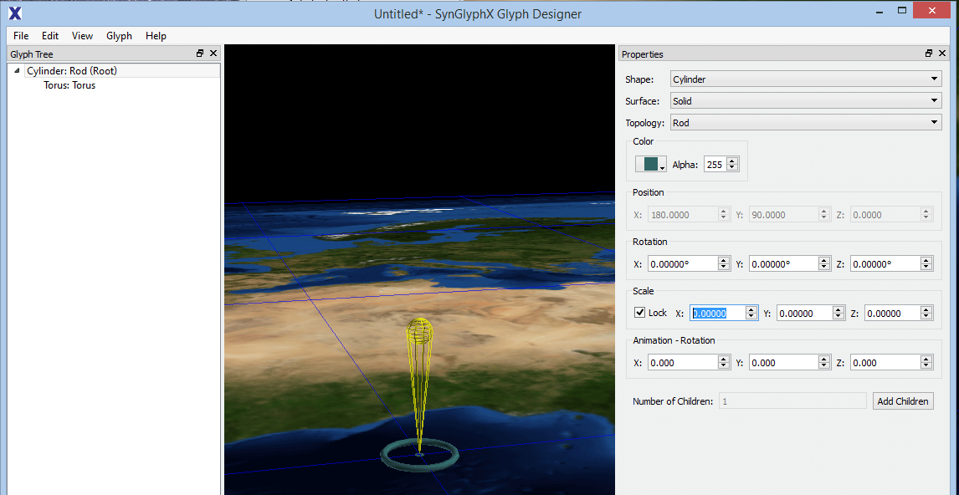

1. Click on the “Add Children” button in the “Properties” menu. The “Add Children” menu will pop up. Set the number to 1 and click OK.

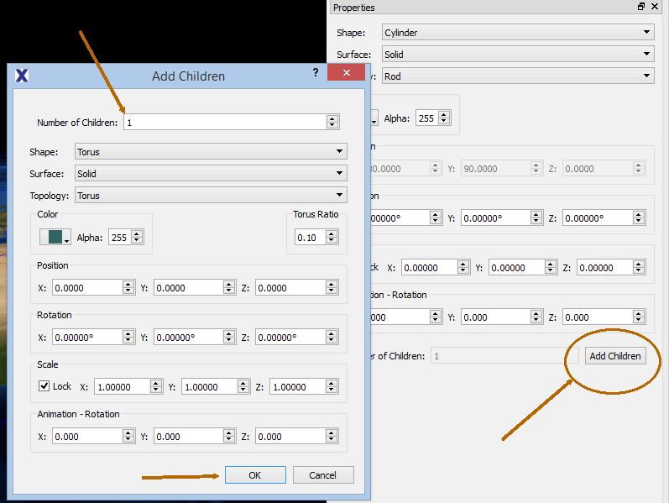

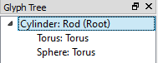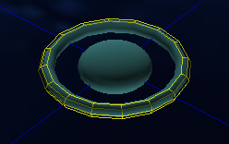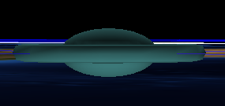

1. Select the first **Torus:Torus** listed in the “Glyph Tree” and change its **Scale** to 0.6.
   1. Change the “Color” to Magenta listed in the dropdown menu.
2. Select the second **Torus:Torus** and change its **Shape** to **Sphere**.
   1. Uncheck “Lock”, then change “Scale” and change the settings to: X=0.5, Y=0.5, Z=0.25.
   2. Change the “Color” to White listed in the dropdown menu.

**NOTE**: Changing the X/Y/Z will carry over to all Children of the glyph element. We are using a pill shape here because it’s easier to stack glyphs over time with a narrower shape profile.

You can also change the transparency to 0 from 255 but in this example it makes no difference.

## Step 6: Create a branch / child for the medal counts

1. 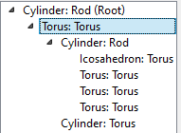Add a branch for the medal count shapes. Select the top **Torus: Torus** 🡺 Add Children: 1 and change the attributes to: **Shape: Cylinder**, **Topology: Rod**, **Alpha**:25 (opacity), **Scale**:0.75
2. Select the **Cylinder: Rod** that you just made 🡺 Add Children: 4. Leave the default settings, as we will change them individually.
   1. Select the top **Torus: Torus** and change it to: **Shape**: Icosahedron, **Topology**: Torus, **Color**: Blue, **Scale**: 3.0
   2. Select the second **Torus: Torus** on the list and change it to: **Shape/Top**: Torus, **Color**: Bronze, **Position**: X= -150°, **Scale**:3.0
   3. Select the third **Torus: Torus** and change it to: **Shape/Top**: Torus, **Color**: Silver, **Position**: X= -120°, **Scale**:3.0
   4. Select the fourth **Torus: Torus** and change it to: **Shape/Top**: Torus, **Color**: Gold, **Position**: X= -90°, **Scale**:3.0

**NOTE**: The X position in Torus topology will let you move glyph elements up and down on the -180 ⬄ 180 degree range.

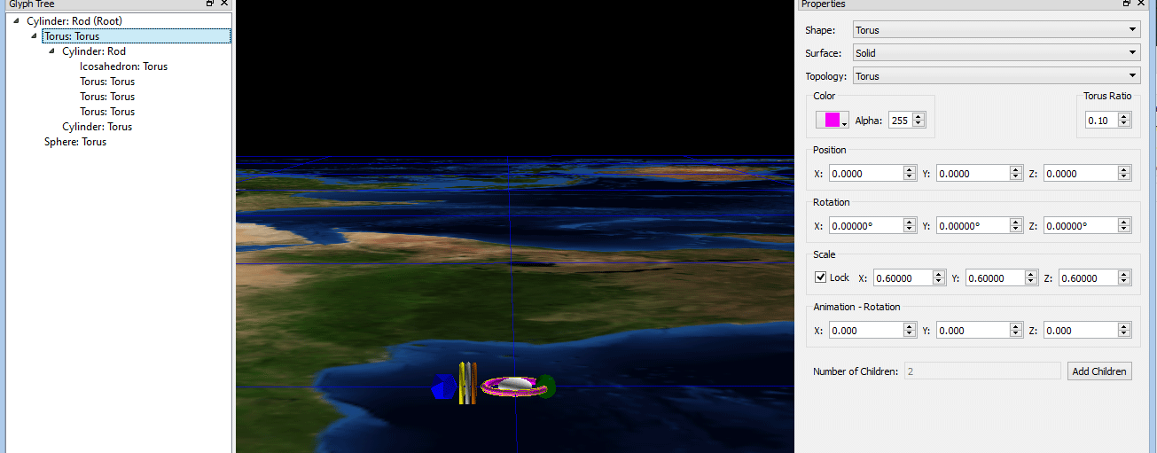

## Step 7: create an element for age

1. Select the (second one down) **Torus: Torus** listed on “Glyph Tree” 🡺 Add Children:1
2. Select that new shape and change the default settings: **Shape**: Cylinder, **Topology**: Torus, **Scale**: 1.0, **Position**: X=180°, **Color**: Green

## STEP 8: We’re done building the glyph

#### Save the glyph under any name

In this example we use “Sample glyph.sgt”. At this point we are ready to move to the Data Mapper stage. The images below are what your finished glyph should look like:



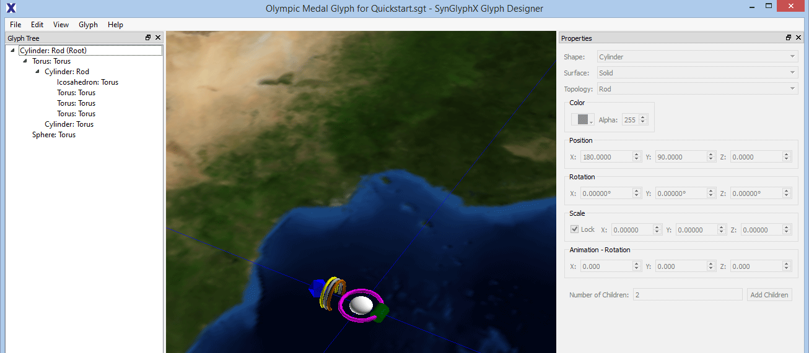

# Data Mapper

#### This is where the fun begins

You can start to assign data and character fields to specific glyph elements.

## STEP 9: Open the data Mapper

Open up the **DATA MAPPER** tool to see an image like the one below.

Notice the following elements marked with arrows:

* **Glyph Tree:** This column will show the glyph elements and is identical to the Glyph Tree column in Glyph Designer. After loading a Glyph this column will be populated. Elements can be added and removed from this column as needed.
* **Grid/Base Images:** This column is where one can assign a map or a user’s own custom images.
* **Data Bindings:** This is where columns from the **Data Stats** field can be dragged and dropped to customize each visualization. With Data Bindings there are tabs to assign Base Properties, Tag & Description, Animation, and Non-Mappable (glyph properties)
* **Data Stats:** This will display summary information broken down by column once a Data Source has been added from the main menu. Field Name, Type, Min/Max/Average, and Count will be shown.

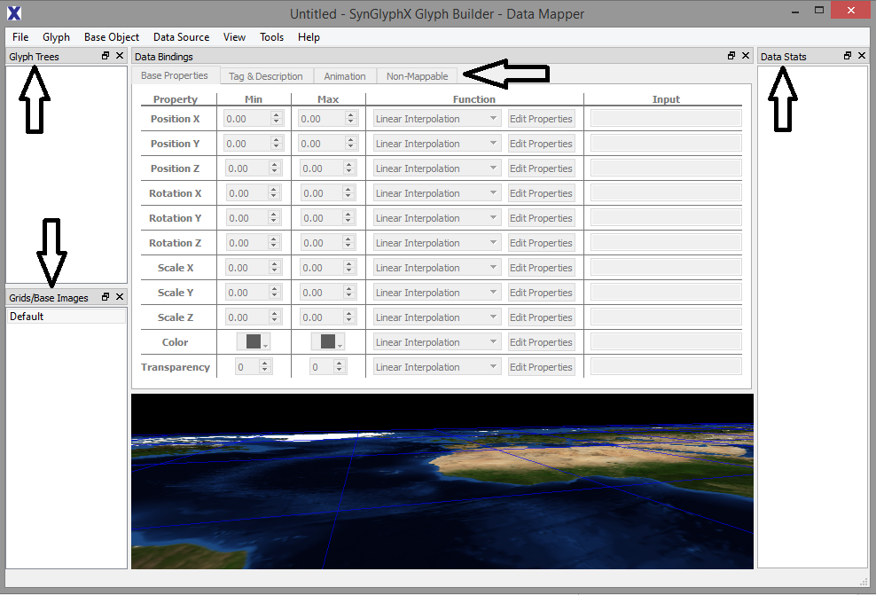

## STEP 10: get the MapQuest Key and add it to the data mapper

Before we begin, you will need to download a MapQuest key so that any lat/long coordinates in your data sources can be properly placed on an underlying image.

1. Navigate here: <https://developer.mapquest.com/plan_purchase/steps/business_edition/business_edition_free>

2. Fill in the information requested. Make sure to check the box saying you agree with the terms of use. If the link above is still broken (they have been doing work on this portion recently) refer to the key below (STEP 11). This should work for the time being.

3. Click on CREATE NEW ACCOUNT.

4. Wait for email from mapquest. When it arrives, click on the link in the email.

5. Go to <https://developer.mapquest.com/user>

6. Click on KEYS AND REPORTING.

7. Click on MY APPLICATION.

8. You will now see a page that lists your CONSUMER SECRET (not important) and your CONSUMER KEY (important). The latter is your application key.

9. Open either GlyphViewer or DataMapper and open Tools 🡺 Map Download Settings

10. Paste the mapquest key

11*. If the MapQuest Key site is broken, use this for now: Fmjtd%7Cluurn1ua2h%2Crw%3Do5-9wyn5u

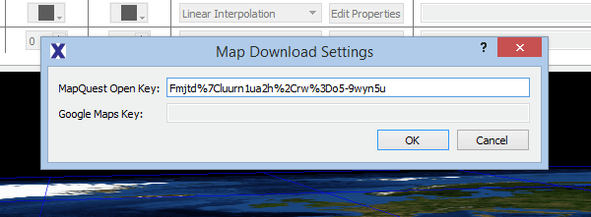

## STEP 11: import the data and assign fields

1. Open **Data Mapper 🡺 Data Source 🡺 Add Data Sources 🡺 “Sample data.csv**”
2. 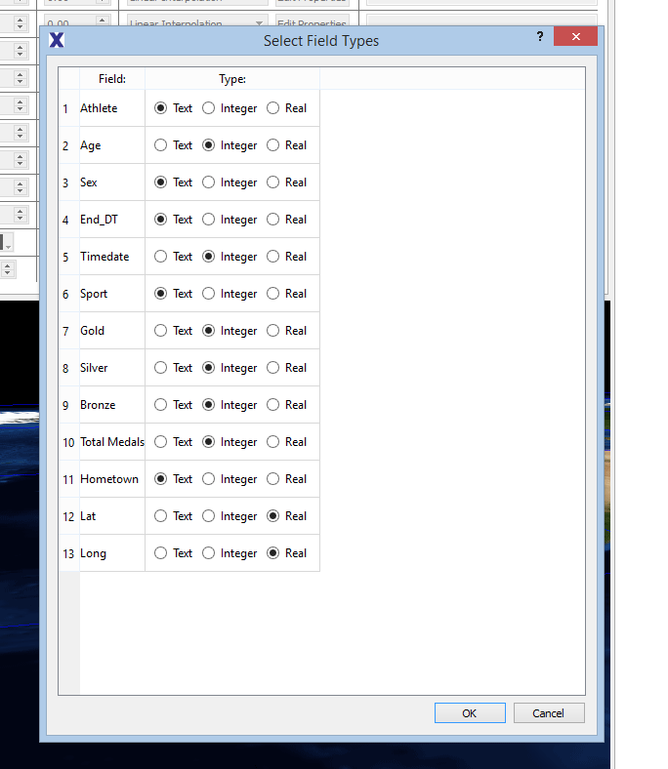Select the proper elements for each field (you can have the base file open simultaneously if you are unsure about each column).

Note that you cannot assign a Field Name to “text” and then later drag that element to a Base Properties Input unless you are using the “Text Field to Value” function.

1. You now should have the “**Data Stats**” window populate on the right with the data set’s summary information. It should look something like the sample below:

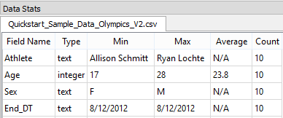

#### Trouble Shooting – If there are issues loading in the data, the following checks SHOULD be done.

* Make sure there are no spaces in the column names
* Make sure there are no random populated fields in your data source
  + This can be done by filtering each column and checking for [blanks] as a field
* Remove any commas from the fields to prevent row mismatching
* Make sure each column name is unique
  + A simple check here if using Excel is to select all columns, right click 🡺 paste special 🡺 transpose to get them all in a single column, and then data 🡺 remove duplicates. If anything is removed then you will need to rename or remove the duplicates
* Check that each type field is uniform (i.e. no real values in the integer column)
* Check that numeric fields are not assigned as free text in your data source

## Step 12: Import Glyph

#### Import Glyph

1. Open **Glyph 🡺 Add Glyph Templates 🡺 “Sample glyph.sgt**”. This will populate the central region with your previously created glyph.
2. You can see your Glyph in the far left column “**GLYPH TREE**”. Click on all of the arrows on the Glyph Tree to open all shapes. This will be your working template as you map each field. You can also click directly on the glyph elements themselves (but as you graduate to much more complex visualizations, it is easier to mistakenly select things).

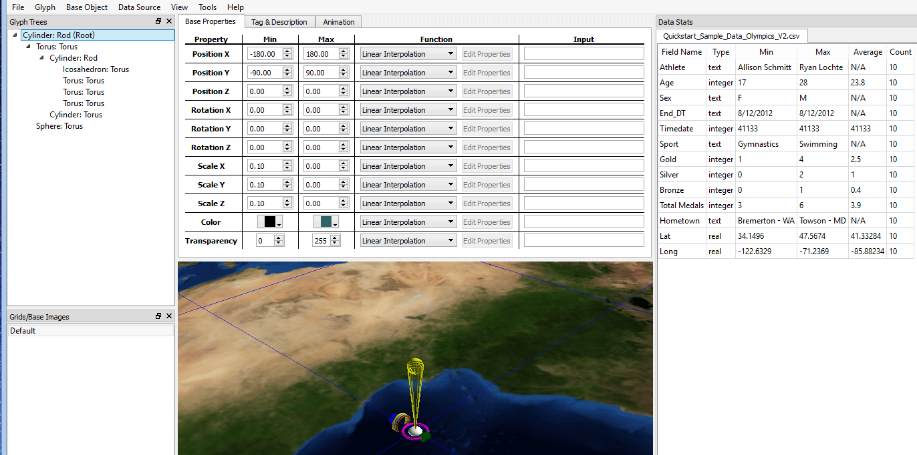

## Step 13: Define base image

1. Click on **Base Object 🡺 Properties** 🡺
2. Click on button **🡺 Base Image Type: Downloaded Map 🡺 Type: Map**

NOTE: You can load a variety of interesting images and legends in this section. Once you have gained more familiarity with this field try experimenting with new maps and grids.

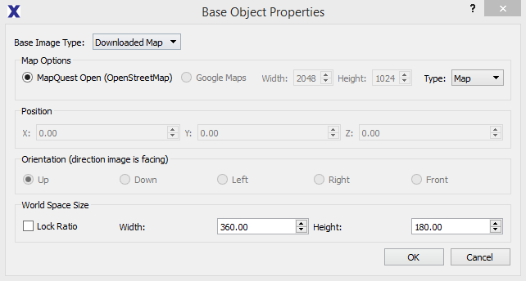

## Step 14: map data to glyph

The process for mapping the data to the Glyph is simply to drag the data from the “Data Stats” area and drop it into the appropriate field in the “Input” area of “**Base Properties**”. The same drag and drop also applies to the “**Tag & Description”** fields but keep in mind that only Text fields are allowed.

1. The first property that we want to map is the root glyph, listed in the “**Glyph Tree**” column. In this case it is a **Cylinder: Rod (Root)**. Be sure that glyph is selected (it has a blue highlight to indicated it is selected) and its base properties will appear in the window. You will need to drag the data from the right column into the Input area of the middle column.
   1. Drag the Longitude data into Position X
   2. Drag the Latitude data into Position Y
   3. Drag the Timedate data into position Z. Change Min/Max values to 5 so the glyphs will float above the map layer.

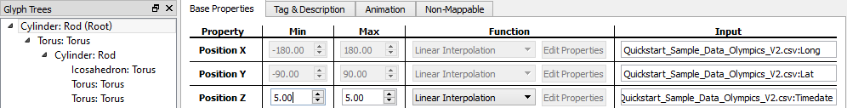

Note: The min/max values are greyed out in Position X/Y because a downloaded map has been specified and it assumes geo located Lat/Long values will be used.

NOTE: Currently this sample data is from one period of time, but if you add more information to the data set later on you will not have to go back and remap this value. Also notice the Min/Max values. If you change Max=5 (or some other value) it will float the glyphs above the map layer.

#### Continue mapping the other objects

1. Select the **Cylinder:Torus,** and drag the **Age** data over to **ScaleX/ScaleY/ScaleZ**. This will require three drags and change the **Min values for X/Y/Z = .61**.
   1. Drag the **Age** data over to the “**Color**” field under “**Base Properties**” and change the Min/Max colors to **Min/dark-green & Max/light-green**.

NOTE: At the end of this guide there is a special section on sizing, but currently we will assume that the Max values established from the initial setup are correct. Data Mapper defaults to Min (in data) = Min (size) which is typically not what you want. In this case, relative Min = 17/28 = .61.

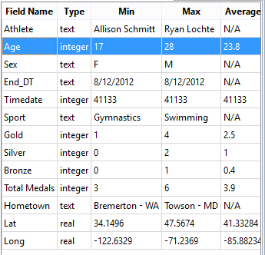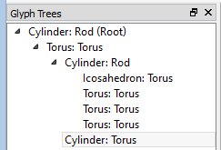

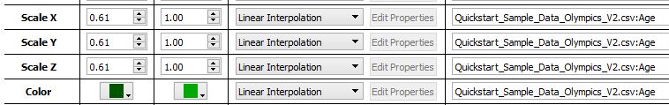

1. Finally we will map the medal counts and totals
   1. Select the **Icosahedron: Torus** in the “**Glyph Trees**” and drag the **Total Medals** data from the **Scale** fields to the **X/Y/Z fields**. This requires three drags. Change the **Scale** to **Min X/Y/Z = 3/6 *(3) = 1.5**, **Max = 3.0**

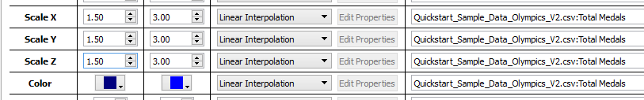

* 1. Select the first **Torus: Torus** in the “Glyph Trees” and drag the **Bronze Medal** data to the **Scale** field to the **X/Y/Z** fields. Change the **Scale to Min X/Y = 0, Scale Max X/Y = (1/4)*(4) = 1.0.**

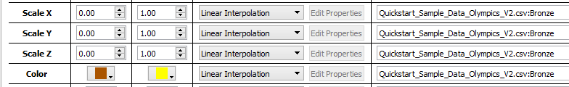

* 1. Select the second **Torus: Torus**, in the “**Glyph Trees**” and drag the **Silver Medal** data from the **Scale** field to the **X/Y/Z** fields. Change the Scale for **X/Y** to **Min X/Y= 0, Scale Max X/Y = (2/4)*(4) = 2.0**

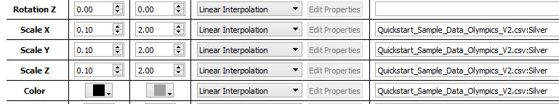

* 1. Select the third **Torus: Torus** in the “**Glyph Trees**” and drag the **Gold Medal** data from the **Scale** field to the **X/Y** fields. Change the Scale for **X/Y** to **Min X/Y= .75, Scale Max X/Y = (4/4)*(4) = 4.0**

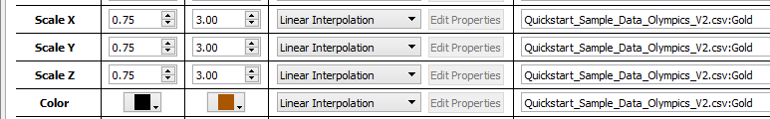

NOTE: You will notice that the glyph elements will grow or shrink as you modify the Min/Max values. Data Mapper is set up to show how large the Max will be for each element. If you are unsure whether a Min is too small, you can play around with that value in the Max column to get quick visual feedback before finalizing everything.

## Step 15: addING Tag AND Description information

The Tag & Description fields are filled using the “**Text**” fields from the data. This is used when viewing the finished visualization. You can select the “I” key and this text field will display.

1. To add a text description to this object, make sure the **Cylinder:Torus**, is still selected. Click on the “**Tag & Description**” Tab located next to “**Base Properties**” and drag the text field for Athlete to the Tag area.

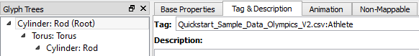

## Step 16: MAPPING DATA TO SHAPES

In order to map the females to males we will need to use the “Text Field to Value” function. This function maps a color to a text field.

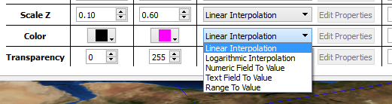

1. Select the **Torus:Torus**, in the “**Glyph Trees**”
2. Drag the **Age** “Field Name” over from the “**Data Stats**” window to the “**Color**” field in “Base Properties” window.



1. In the “Function” field choose the “**Text Field to Value**”
   1. Edit Properties, Key: M – Value: Blue, Key: F – Value: Pink. This will map the females to pink and males to blue

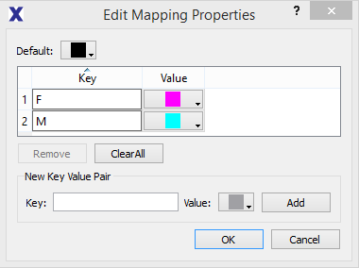

NOTE: If you have a typo or forget to map all of your unique text values in the text to value mapping it will default to your Default color (in this example it is black) which can be changed to user specification.

## Step 17: Save file

After that last click you should be finished! Save the file. We used the file name, “**Sample datamap.sdt**.”

# Glyph Viewer

Before loading the *.sdt file, first open Glyph Viewer and you will see a screen like this:

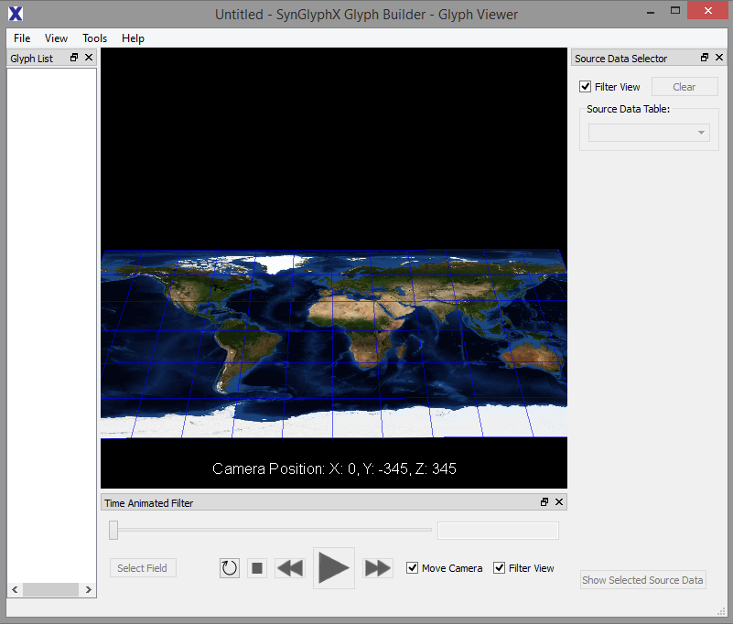

There are 4 main parts to Glyph Viewer.

1. Glyph List: This is where the mapped data elements will appear after loading the sdt file and each data element can be selected from the Glyph List and highlighted within the field of view
2. Source Data Selector: This will be populated with an elastic list for selection / filtering once the data is loaded. Elements selected within the Data Selector will be identified in the field of view
3. Time Animated Filter: This toolbar allows the user to select a column field on which to animate through its value range (such as time). The sliding bar lets the user manually progress while the play button will auto-step every 1 second.
4. Field of View:

Simply open **Glyph Viewer 🡺 File 🡺 Open Visualization 🡺 “Sample datamap.sdt**.”

Depending on the file size, it may take a bit of time to view, and often it may also zoom into a single element once loaded.

The nice thing about Glyph Viewer is that all data will be shown in the Glyph List. Clicking on each element will snap to location, and that makes navigating very easy. A sample screenshot of the New England region is shown below

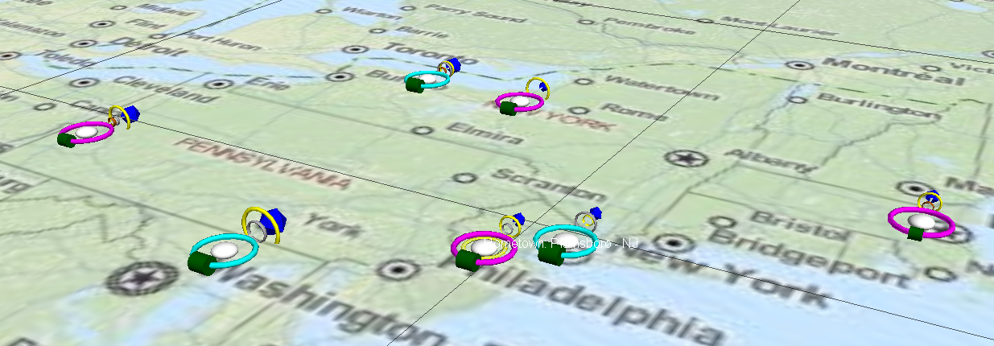

For now the main navigation commands are:

* Drag Left/Right = Rotate View
* L+R Mouse + Forward = Zoom In
* L+R Mouse + Backward = Zoom Out

# Portable Viewer

# Exporting to Portable Viewer

While the Glyph Viewer can natively read in *.sdt files, Portable Viewer needs you to create a new folder and export from Data Mapper. Once you have an empty folder created on your desktop, go to File 🡺 Create Portable Visualization 🡺 select the desired folder. After that, you can open that folder, go to glyphviewerportable.exe, press “1”, and the data will load.

If you are using the sample data you will see something like this:

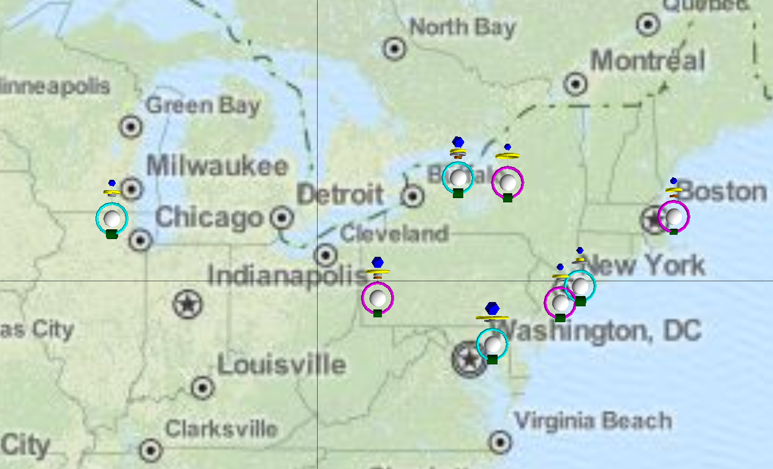

### General Navigation

Notice that you are in “**mode:Pin**”. This default mode will let you select elements and pull their information as well as navigate the viewing area. The navigation commands are:

* Mouse Drag Left/Right = Rotate View
* L+R Mouse + Forward = Zoom In
* L+R Mouse + Backward = Zoom Out
* And the selection / exploration commands are:
* Left Click (on element) = Select Single
* Right Click (on elements) = Select Multiple
* “I” (after selecting) = Display Information
* Toggle “I” (after displaying information) = Change Color / Hide Information

Change mode to “ **mode:Camera**”:

* a increase X
* d decrease X
* w increase Y
* s decrease Y
* e increase Z
* q decrease Z

# how to guide

## Background Image

The color, quality, and look of the background image map should be considered for the final visualization. An overly complex background can easily confuse the viewer and the glyphs can be difficult to see. There are many options available to either change the background or create a custom background for the visualization.

The “Data Mapper” tool has three options for the “**Base Object**” (or background image). By going to **Base Object 🡺 Properties** and the “Base Image Type” a dropdown menu is available with three options:

* Default: World map
* Downloaded Map: Used with Latitude/Longitude coordinates from the data
* 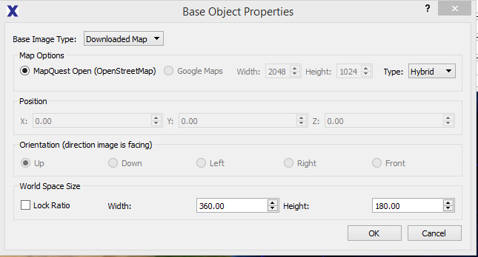Local Image: Create original graphic and load locally

For this demo, we are going to edit the MapQuest downloaded map to improve the quality of the visualization. The image below illustrates how the background image and glyphs look using the default downloaded map from MapQuest:

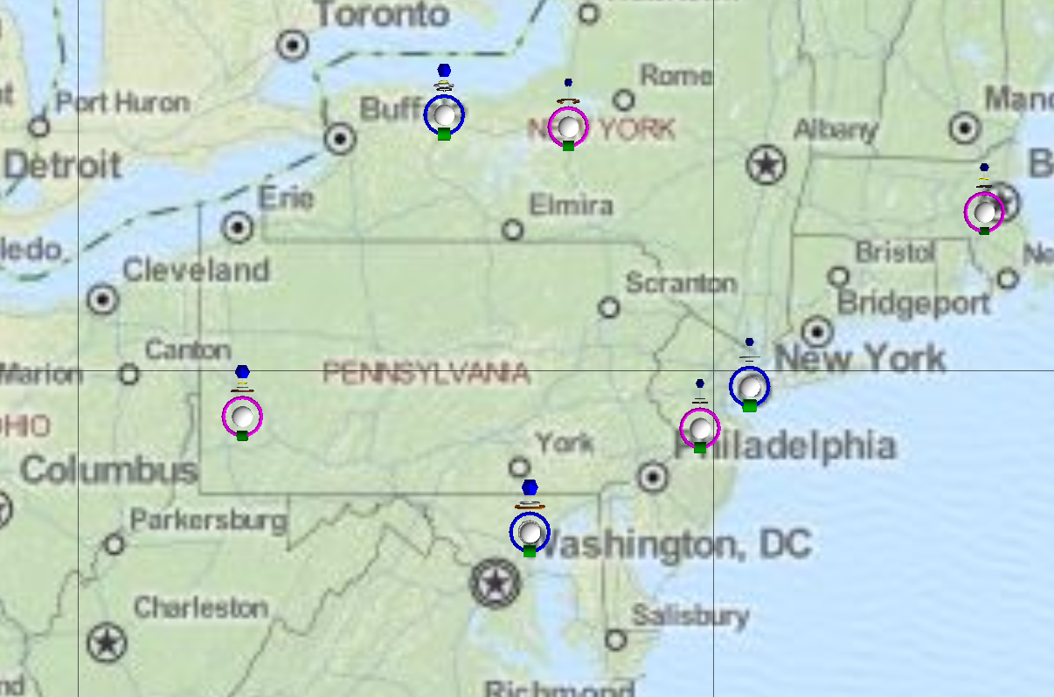

To change the background image map

1. Navigate to the Portable Visualizer folder **usr 🡺 images**. A screenshot is shown below

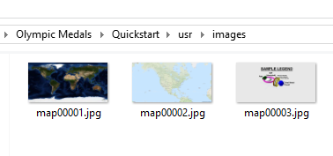

1. Open the main background image, named “**map00002.jpg**”, in a photo/bitmap editor program. In this example we’re going to use a free program called paint.net, (download it here: [www.getpaint.net/download.html](http://www.getpaint.net/download.html) )
2. Navigate to **Adjustments 🡺 Black and White** (or press Ctrl+Shift+G) changing to black/white, and “Save” the image.

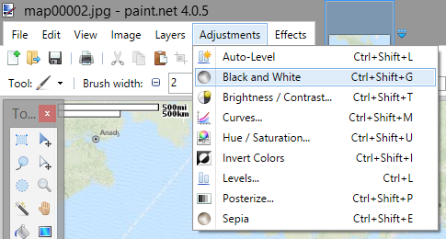

1. The visualization will now have a grey scale base image during subsequent times opened.

This is a simple modification to the base image that will help the readability of the glyphs on the map.

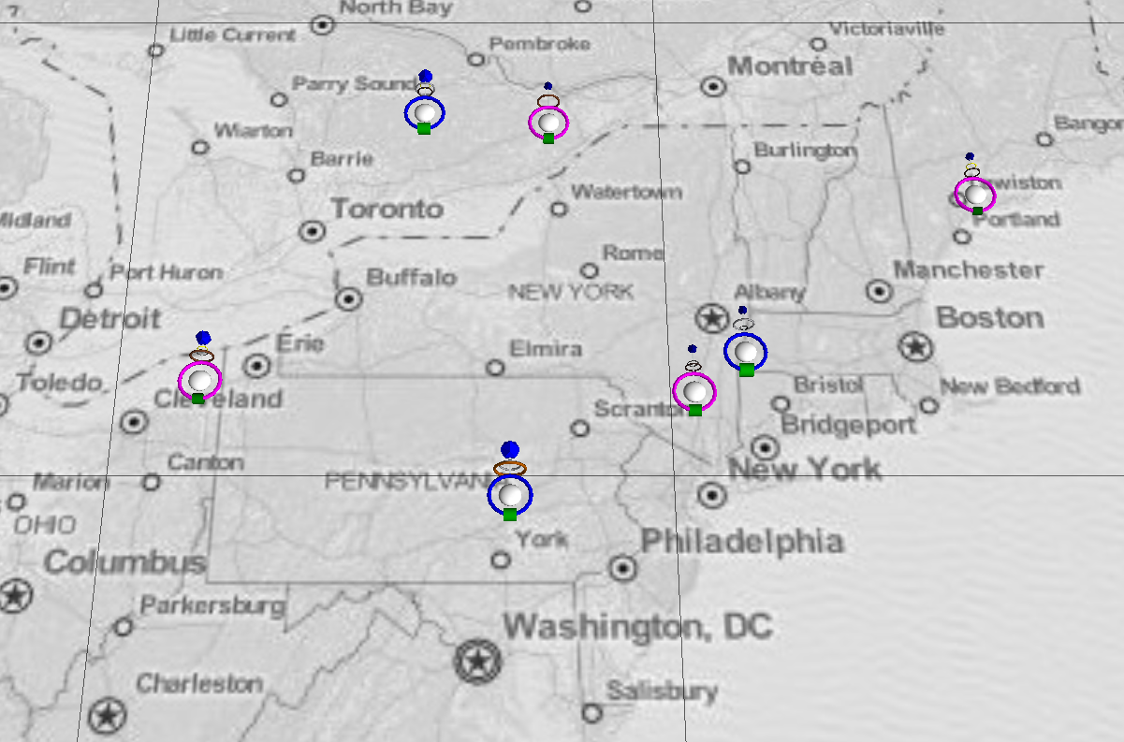

## Add Glyph Legends

#### Creating Legends for Glyph Viewer and Portable Viewer

Legends are a quick way to convey exactly what each glyph element means without depending too much on the Glyph List (in Glyph Viewer) or “I” key in Portable Viewer.

#### To set one up:

1. Create a 2048 x 1024 image file. This can be done in several programs such as MS Paint.
2. Grab a screen cap or two (or three depending on the complexity) of your glyph design

NOTE: Glyph Designer pulls the “world.png” file as its background. If you want a neutral color, this file will have to be replaced with your desired “world.png” image. Typically a neural solid color is a good choice to minimize distraction.

1. Label each element and paste the results into your image file. Save the file as *.png
2. Open the Data Mapper file where you want to place the legend.
3. Go to Base Object 🡺 Add Base Object
4. Base Image Type: Local Image 🡺 Navigate to your Legend
5. Position and orient the Legend to your choosing. For example if you want the image facing the front then X: 0.00, Y: 90.00, Z: 90.00 and Orientation: Front
6. Click “OK” and then your Legend should be loaded and positioned properly

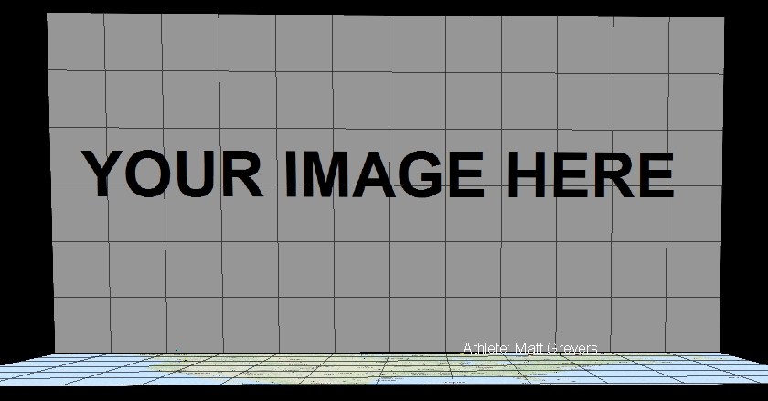

1. If you want to create a legend on Left or Right, use the following XYZ values: Left: X:-180.00, Y: 0.00, Z: 90.00 – Orientation: Right – Height:180.00

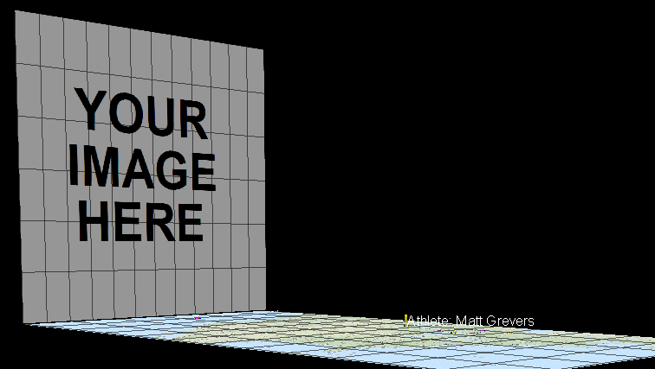

1. Right: X:180.00, Y:0.00, Z:90.00 – Orientation: Left – Height: 180:00

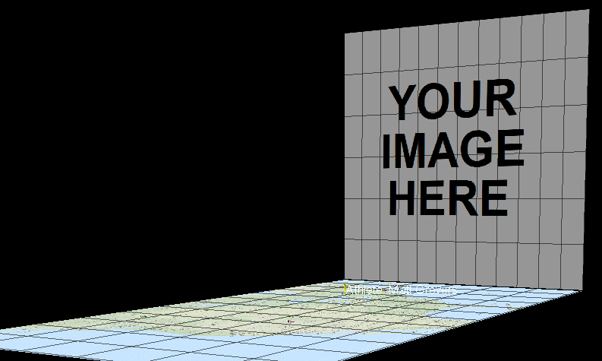

NOTE: Left/Right use square image spaces (1:1) instead of rectangular ones (2:1). Despite this, Data Mapper STILL REQUIRES a 2048x1024 image. To make things look nice, you will have to create your desired image and then use MS Paint (or another program) to stretch the ration back to 2:1. This can be done for example by opening the image, clicking on “Resize” and unchecking “Maintain Aspect Ratio”

## Modify the Glyphs and Add new information

Once you have your Data Set, Glyph Design, and Data Map elements in place, you can update and change information quickly.

#### Example 1: I want to modify the Glyph Design and move elements from one parent location

Version 11 allows the user to natively create and modify the loaded glyph template in Data Mapper. Once that program is loaded, simply right clicking on a parent glyph element will open the “Add Children” option. This will bring up the standard GUI used in Glyph Designer.

If you accidentally create a glyph element in the wrong location, you can drag and drop it in its proper place. This action can only be done in the “Glyph Tree” location, not in the sample view.

#### Example 2: I want to modify the Glyph Sizes and heights

Let’s say the output looks a bit too close to the map (base image), and the glyphs themselves are too small.

* Open **Data Mapper** 🡺 **Load the Sample** 🡺 **Cylinder:Rod(Root),**
* Change **Max Position Z: 10** 🡺 **Torus: Torus, Scale X/Y/Z: 1.00** 🡺 **Sphere:Torus, Change Scale X/Y: 0.75**

This will make the glyphs larger (and you only need to modify the top level because everything underneath (the child glyphs) will scale) and rise above the map a bit more.

## MoDIFY Column TYPES AFTER MAPPINg

There may be some cases where the user wants to convert a column from one data type into another. For example, the user has a string of numbers with some “N/A” values that have been updated to only numbers and they want to convert a “text” column into an “integer” column.

1. Clear the Data Mapper data cache (the files ending in *.db) in this location:

C:\Users\${USERNAME}\AppData\Local\Temp\SynGlyphX\Glyph Builder - Data Mapper\

[Replace ${USERNAME} with whatever your username is on your machine.]

1. Open the base file’s *.csvt and rename the appropriate column from “TEXT” to “INTEGER”
2. Modify the base file’s data so all non-numeric values are numeric and save.

## add more data and remove some rows

As long as you keep to the data format originally mapped in Data Mapper, you should be able to go back to your original Data Set and add/remove rows at will. Once you re-save the base file everything else will be taken care of.

NOTE: If you do the following, auto-update will not work!

* Add or remove columns
* Leave blank fields
* Add in elements that do not correspond to the mapped types (i.e. real in integer)

## exact Glyph PLacement Using a Custom Background

This section details how to exactly place your glyph elements against a custom background. In this example we will be using the following image below as our base:

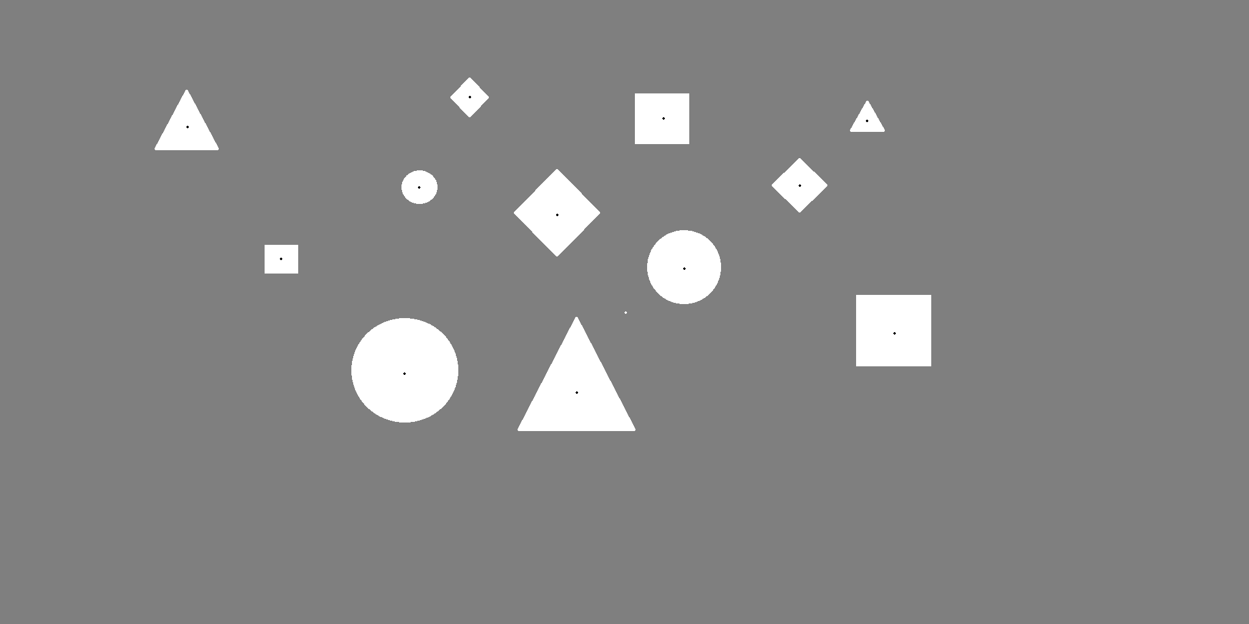

The objective is to exactly place each glyph onto the centroid dots in each shape. As stated earlier in this guide, custom backgrounds must be exactly 2048x1024 pixels in the current version. Because of this restriction, we can use a few transform formulae to take the pixel coordinates and re-map onto the -180⬄180 and -90⬄90 max/min in Data Mapper.

To assist the user, we have included “Pinpoint_Transforms.xlsx” in the Read Me materials section. If you open that file, you will see the following:

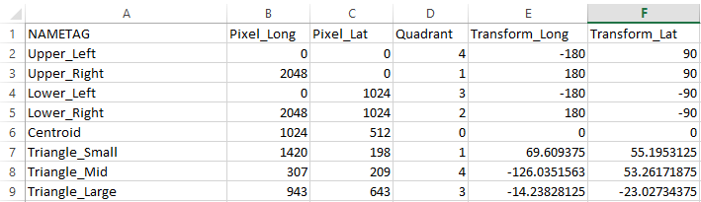

Note that you have 4 Upper and Lower rows that reach the 4 corners of our base image. These base points are going to be used to automatically align our visualization properly and must be loaded into data mapper in some way or form. Underneath we have the image centroid and Triangle centers mapped out to validate that everything is working.

In order to properly place a glyph element on a certain background location, all you need to do is open the background image, type in the XY coordinates, and extend the pre-built equations for Quadrant, Transform_Long, and Transform_Lat.

## modify the rotation values to make the glyph elements orient correctly

#### Rotation Series Calculations

Sometimes a glyph will have directional information attached and you will want to “point” it a specific way (i.e. planes, boats, and cars as they move around over time). The following information below will help you in data processing.

Rotation Y controls directional pointing in DataMapper and is different from a unit circle, and each directional vector can be placed in a quadrant (unless it points straight U/D/L/R).

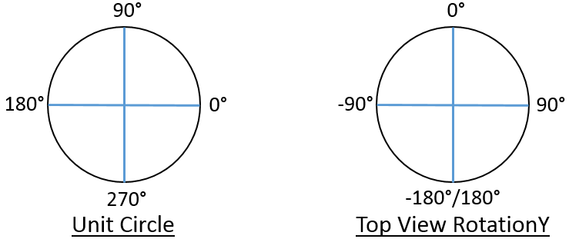 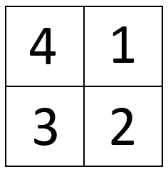

* Using a standard trigonometric function, one can extract a degree (or radian) value
* Latitude change corresponds to ΔY, and longitude change corresponds to ΔX
* Calculating a few derivative values will allow one to transform a vector defined by ΔY and ΔX into a specific RotationY value that can be directly mapped in DataMapper
* The following information is used to define RotationY
* ΔY, ΔX, and HYP
* Quadrant Indicator and Quadrant Adjuster
* Plus/Minus Adjuster
* And the equations below are used (in Excel currently) to create the elements above
* ΔY = Lat 2 – Lat 1, ΔX = Long 2 – Long 1, HYP = SQRT(ΔY2 + ΔX2)
* Quadrant Indicator = IF(AND(ΔY >0, ΔX >0),1,0)+IF(AND(ΔY >0, ΔX <0),4,0)+IF(AND(ΔY <0, ΔX <0),3,0)+IF(AND(ΔY <0, ΔX >0),2,0)
* Quadrant Adjuster = IF(QI=1,90,0)+IF(QI=2,90,0)+IF(QI=3,-90,0)+IF(QI=4,-90,0)
* Plus/Minus = IF(QI=1,-1,0)+IF(QI=2,-1,0)+IF(QI=3,1,0)+IF(QI=4,1,0)

NOTE: QI = Quadrant Indicator from (b.)

Finally we take these elements and compute the RotationY value.

RotationY = IF(QI>0,(QA+(P/M)*(DEGREES(ASIN(ΔY /HYP)))),0)

If done correctly, you will notice that all vectors falling into Q1 will have a RotationY value between 0 and 90, Q2 between 90 and 180, Q3 between -90 and -180, and Q4 between 0 and -90.

## sizing elements

How can I size each element so they are proportional as a whole?

How many degrees should I input to make things evenly spaced in Glyph Designer?

I have several related glyph elements but their sizes don’t seem to match the underlying values. How do I change that?

## Max/Min Guidelines for Data Mapper

The examples below will go through how to assign proportional Max/Min values to each glyph. This section is needed when the user wants to have normalized glyph sizes across multiple related elements but the actual values are stored in different base data columns. Note that Data Mapper values are currently limited to two (2) decimal places, so rounding will occur.

#### Example 1 (Min > 0): Default Glyph Size = 4, Max = 30, Min = 5

This is the simplest case where you may have something like an Age column and do not want the smallest value to be invisible in Glyph Viewer. Because you are only comparing one column, if the default sizing is correct then only the Min values will need to be changed.

Min = (5/30)*(4) = .67

#### Example 2 (Min > 0, resize max): Default Glyph Size = 15, Max = 30, Min =5

Suppose the default size is too large. Once you have decided on the Max Base (i.e. 2) then:

Max = (30/30)*(Max Base = 2) = 2  
Min = (5/30) * (2) = .33

#### Example 3 (Multiple columns): Col 1 [0, 10] / Col 2 [5, 15] / Col 3 [15, 25] / Col 4 [0, 40]

In this last example, you are normalizing across several related columns. Instead of using the local Max as a baseline, this process will use the global Max (which is 40). Let’s use size = 5.

Min 1 = (0/40)*(5) = 0 Max 1 = (10/40)*(5) = 1.25  
Min 2 = (5/40)*(5) = .63 Max 2 = (15/40)*(5) = 1.88   
Min 3 = (15/40)*(5) = 1.88 Max 3 = (25/40)*(5) = 3.13  
Min 4 = (0/40)*(5) = 0 Max 4 = (40/40)*(5) = 5

## Glyph Designer Alignment Charts

For each N=# of children for a circular (360) Glyph, below are the values to space equivalently:

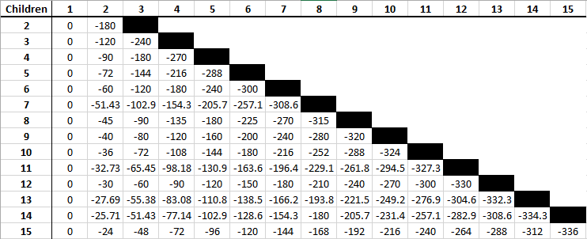

And for each N=# of children on a rod topology (0 to -180) here are the values

